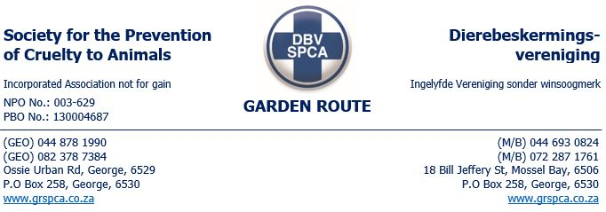
DATE: 28 JANUARY 2025
TIME: 12:40
CONDUCTED BY: Inspector Themba
NATURE OF COMPLAINT: 2 INJURED STRAY DONKEYS
On 28 January 2025, the Mossel Bay SPCA received a complaint from the Glentana area regarding two stray donkeys, one of which was reported to have an injury on its leg. I was assigned to conduct the inspection.
In the afternoon of the same day, I traveled to Glentana. Upon arriving at the farm, I encountered two women who were walking from the direction of the farm I was heading to. I inquired about the stray donkeys, and one of them pointed out the location of the donkeys. She mentioned that they had no information regarding the donkeys' owner. I then proceeded to the complainant’s house. On my way, I spotted two donkeys with a foal. I did not observe any injuries, and the donkeys appeared to be in acceptable condition. I also took photographs of them. The donkeys were roaming alongside a herd of cows that had come through an open gate.
I then arrived at the complainant's house, where she greeted me. I introduced myself and explained the purpose of my visit. She showed me the two donkeys that were now under her care. The adult donkey had two cuts on its front and hind right legs. The injuries appeared to be not recent (not fresh), and it was evident that a purple wound spray had been applied recently.
When asked how long the donkeys had been roaming and in her care, the complainant confirmed that they had been with her for about 24 hours. I also inquired about the other three donkeys I had seen earlier on my way to her house. She stated that she was not aware of the other three donkeys roaming freely in the area.
I then spoke with some of the farm workers. One worker told me that the donkeys were herding with the cows and that they belonged to Danie. He offered to provide me with the contact number for the donkeys' owner and also gave me directions to his fruit-selling business. I followed these directions but was unable to locate the owner, Danie.
At that time, no further action was taken. The two donkeys remained in the care of the complainant, who had no issues housing them until further assistance could be arranged. The other three donkeys were safely returned to the herd.
The action plan at that time was to remove all five donkeys as stray animals. I made a telephone call to Danie, who initially denied ownership of the donkeys. About 20 minutes later, he called back to confirm that he was indeed the owner and stated that he would go to remove them. He mentioned that they would be housed on his farm. I responded by informing him that, since the donkeys had escaped for their own safety, an inspection needed to be conducted to ensure they were properly housed and cared for.
On 29 January 2025, I contacted Danie to arrange a visit to his farm for the inspection. However, he became rude during the conversation. I then reached out to the complainant, who, at this point, informed me that she now knew where the donkeys came from and where they were being kept. She further stated that the owner had come the previous day and removed all five donkeys.
I asked if she could provide me with the location of the donkeys. It was later discovered that this case fell outside the Mossel Bay Municipal area. After discussing the matter with management, a decision was made to request the George SPCA to conduct a follow-up inspection at Danie’s property, where all the donkeys are now housed, and to ensure that the injured donkey receives the necessary treatment.

