Cape Exotic Animal Hospital
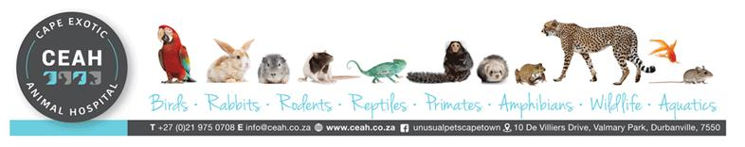
10 De Villiers Drive
Valmary Park, Durbanville 7550

30 August 2023
Patient: Molly
Client: Madeleine Tolken (Brackenfell Pets)

History:
Molly is a Cockatoo that has been a patient at Cape Exotic Animal Hospital since 24/10/2019. According to the owner Molly was rescued by them a week earlier and presented on 24/10/2019 with no feathers on the head, body or back and signs of mutilation of the feathers. Molly was diagnosed and treated for metal toxicity (zinc). On 05/11/2020, Molly presented again for feather plucking. Zinc levels were retested and came back within normal limits. On 25/02/2022, Molly was seen for an avian routine. On 17/02/2023, Molly presented for decreased appetite and being puffed up, and was diagnosed and treated for aspergillosis. Zinc levels were also retested and came back within normal limits.
Health check:
Molly was seen on 30/08/2023 for a health check. According to the owner, Molly is not actively plucking or mutilating the feathers. On the clinical exam Molly still had no feathers on the ventral body and dorsal wings and primary feathers showing signs of mutilation. Further on clinical examination, no abnormalities were detected, and Molly seems to be in good general health. A routine vitamin ACE injection and Ivomec drop topically was given.

Please let me know if you need any further information.

Kind Regards
Dr Jana Basson (BVSc)
Cape Exotic Animal Hospital

