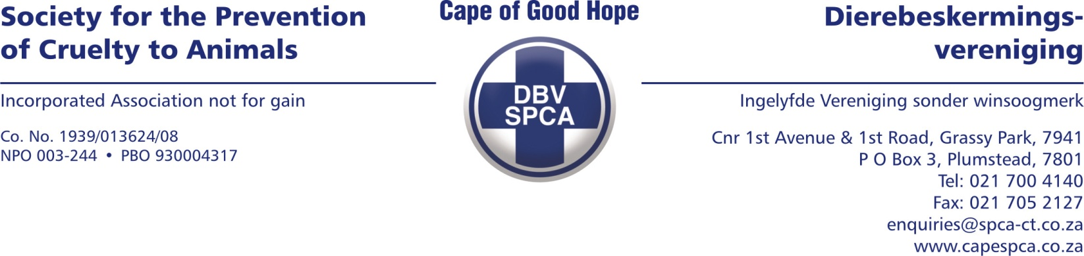

AFFIDAVIT – VETERINARY REPORT

I, Dr. Leon Hector, hereby make oath and declare in English as follows:

1.
I am an adult male veterinarian registered with the South African Veterinary Council (SAVC) under registration number CS25/19195. I hold a Bachelor of Veterinary Science degree (BVSc). I am currently employed by the Cape of Good Hope SPCA. I am competent to provide veterinary services and experienced in identifying clinical signs of neglect and cruelty in animals.

2.
The facts contained in this affidavit fall within my personal knowledge unless indicated otherwise or unless it appears so from the context. The facts are also, to the best of my knowledge and belief, both true and correct.

3.
On 09 April 2026, I conducted an initial clinical examination of a canine admitted into the care of the Cape of Good Hope SPCA. The animal had been seized from a property situated at 52 Rotterdam Road, Bay View, under Cape of Good Hope SPCA case number INSP229204.

  - ANIMAL INFORMATION:

The details of the animal are as follows:

- Admission Number: A93691
- Species: Canine
- Breed: Boerboel
- Sex and Reproductive Status: Male, intact
- Colour and Markings: Brindle and white
- Microchip: Unknown
- Name: Dingo

  - CLINICAL EXAMINATION FINDINGS:

Upon clinical examination, the following findings were recorded:

- Body Condition Score: 3/9 (underweight)
- Weight: 35.14 kg
- Behaviour: Bright, alert, and responsive.
- External Parasites: Tick infestation present
- Dentition: Within normal limits
- Nails: Within normal limits
- Eyes: Within normal limits
- Additional clinically significant findings:
  - Underweight with tick infestation

4.
VETERINARY OPINION:
The dog was found to be underweight and infested with ticks. These findings are consistent with prolonged inadequate nutrition and insufficient general husbandry. The body condition and parasite burden indicate that the animal had not received an appropriate standard of care.
The duration of suffering is assessed to have been weeks to months.

5.
PROGNOSIS AND RECOMMENDATIONS:

The prognosis at the time of the initial examination was considered good, provided that appropriate veterinary treatment, adequate nutrition, parasite control, and ongoing management were implemented.

6.
INITIAL CONCLUSION

The animal was found to be underweight and affected by a tick infestation. These findings were indicative of neglect in respect of nutrition and general care. At the time of the initial examination, it was considered that the animal could potentially be returned to the owner, subject to strict conditions, including owner education, appropriate veterinary treatment, and regular follow-up inspections to ensure compliance and safeguard the animal's welfare.

7.
On 27 July 2026, I conducted a follow-up clinical examination of the above-mentioned animal.

  - CLINICAL EXAMINATION FINDINGS:

Upon clinical re-examination, the following findings were recorded:

- Body Condition Score: 3/9 (underweight)
- Weight: 35.15 kg
- Behaviour: Bright, alert, and responsive.
- External Parasites: Tick infestation present
- Dentition: Within normal limits
- Nails: Within normal limits
- Eyes: Within normal limits
- Additional clinically significant findings:
  - The dog remained clinically underweight despite receiving nutritional support while in SPCA care.
  - Wounds were present on the left forepaw and between the digits of the right forepaw.

8.
VETERINARY OPINION:
At the time of the follow-up examination, the dog continued to exhibit a poor body condition with minimal improvement in weight despite receiving appropriate nutritional support. Tick infestation remained evident, and wounds were observed on the left forepaw and between the digits of the right forepaw. These findings indicate that the animal had suffered from prolonged neglect and inadequate husbandry prior to admission into SPCA care.
The persistent poor body condition demonstrates that recovery from chronic malnutrition requires a prolonged period of rehabilitation and is consistent with long-standing nutritional deprivation.
9.
PROGNOSIS AND RECOMMENDATIONS:

The dog continues to require nutritional rehabilitation, veterinary treatment for the tick infestation, appropriate wound management, and ongoing monitoring until an acceptable body condition is achieved.

Based on the chronic neglect observed, including prolonged inadequate nutrition, persistent poor body condition, external parasite infestation, and associated wounds, it is my professional opinion that the animal should not be returned to the owner. The findings raise significant concerns regarding the owner's ability to provide the minimum standard of care required to ensure the animal's welfare.
10.
CONCLUSION
In conclusion, the clinical findings recorded during both the initial examination on 09 April 2026 and the follow-up examination on 27 July 2026 demonstrate that the animal had suffered from prolonged neglect. At the initial examination, the dog was underweight and infested with ticks, findings consistent with inadequate nutrition and poor general husbandry. Following admission into SPCA care and the provision of appropriate nutrition and veterinary treatment, the dog's condition showed little to no meaningful improvement in body weight over the intervening period, remaining at a Body Condition Score of 3/9 with virtually no increase in weight.
The persistence of the poor body condition, together with the continued tick infestation and the presence of wounds affecting both forepaws, indicates that the animal's condition was chronic in nature and that significant rehabilitation remains necessary. These findings support the conclusion that the dog endured unnecessary suffering over an extended period as a direct consequence of inadequate care.
11.
I know and understand the content of this declaration.
I have no objection to taking the prescribed oath.
I consider the prescribed oath to be binding on my conscience.

_____________________________
DEPONENT
Dr. Leon Hector (BVSc)

The deponent has acknowledged that he knows and understands the contents of this affidavit/declaration, which was signed and sworn to before me at ____________________ on this the _____ day of ________________ 20___, the regulations contained in Government Notice No R1258 of 21 July 1972, as amended, and Government Notice No R1648 of 19 August 1977, as amended, having been complied with.

_____________________________
COMMISSIONER OF OATHS

Full names: _____________________________________________________________

Designation: ____________________________________________________________

Business address: ______________________________________________________

